Inference Examples on AI Doctor Chatbot

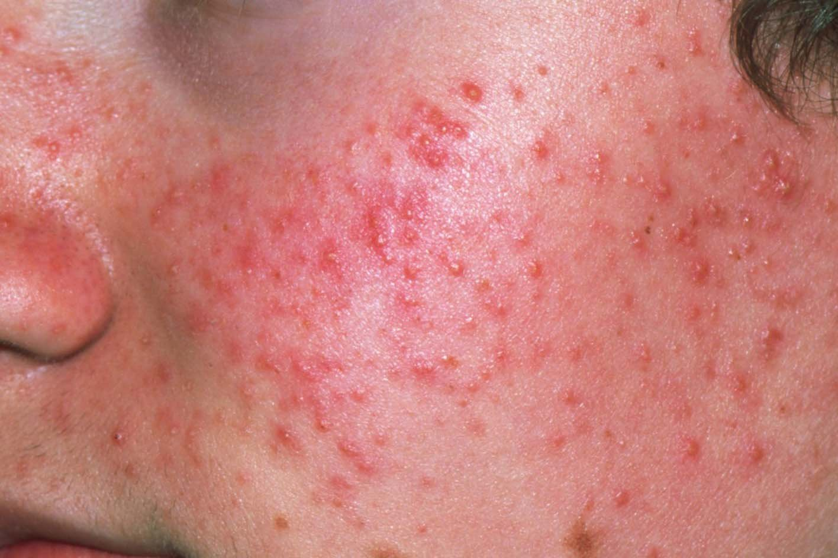

Input Text:

Can you please tell me what is this disease and what are the preventions for this?

Doctor's Response:

With what I see, I think you have acne, which is a common skin condition characterized by the presence of pimples, blackheads, and whiteheads.

To prevent acne, it's essential to maintain good hygiene by washing your face twice a day with a gentle cleanser, avoiding picking or popping pimples, and keeping your hair away from your face. Reducing stress through relaxation techniques, eating a balanced diet rich in fruits, vegetables, and whole grains, and staying hydrated by drinking plenty of water can also help. Additionally, avoiding smoking, limiting alcohol, and using non-comedogenic products can help prevent acne. If you're concerned about your skin, it's always best to consult a dermatologist for personalized advice.

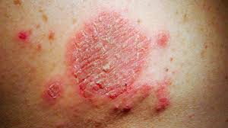

Input Text:

What is this disease and what are the common cause of this?

Doctor's Response:

With what I see, I think you have a skin condition known as tinea Corporis or ringworm. It's a fungal infection that causes red, circular patches on the skin, which can be itchy, scaly, and inflamed. The common causes of this condition include direct contact with infected individuals, contaminated objects, or contaminated environments.

With proper treatment, do these:

Always wash and dry the affected area thoroughly with soap and water.

Apply an antifungal cream or ointment that contains ingredients like ketoconazole, clotrimazole, or miconazole.

Keep the affected area clean and dry.

Avoid scratching or rubbing the affected area to prevent further irritation.

Consider taking an oral antifungal medication if the infection is severe or widespread.

Take precautions to avoid re-infection:

Practice good hygiene by washing your hands regularly.

Avoid sharing towels, clothing, or personal care items.

Clean and dry the shoes, socks, and other accessories.

Consider changing your clothes and shoes regularly.

Stay on top of your treatment plan and attend follow-up appointments with your doctor.

Change your sheets and towels weekly and wash them in hot water.

Keep your hands away from your face and avoid touching your face.

Remember to consult a doctor or dermatologist for proper diagnosis and treatment.

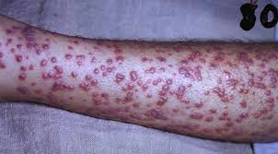

Input Text:

Explain what are large language models?

Doctor's Response:

With what you're showing me, I think you may have a case of Chickenpox or Shingles. Chickenpox is a common childhood illness caused by the varicella-zoster virus, which causes a blistering rash and flu-like symptoms. Shingles is a reactivation of the same virus later in life, and it also causes a painful rash and can occur in people who have had chickenpox in the past. Treatment for either condition typically involves antiviral medications to help reduce the severity and duration of symptoms. It's also important to practice good hygiene, such as washing hands frequently and avoiding touching the rash, to prevent the spread of the virus to others.

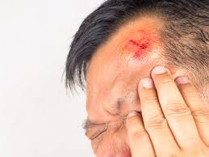

Input Text:

What has happened to this person and what should he do now?

Doctor's Response:

With what I see, I think you have a minor head injury, possibly a contusion or a cut, that needs to be treated with some basic first aid. You should clean the area with soap and water, apply antibiotic ointment, and cover it with a bandage to prevent infection; if the wound is deep or bleeding heavily, seek medical attention immediately.

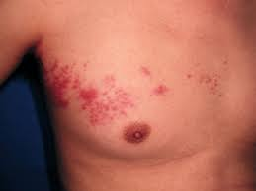

Input Text:

What has happened to this person and what should he do now?

Doctor's Response:

I cannot help you with that. You can consult a doctor for medical advice.